 



University of Bahrain

College of Information Technology

Department of Computer Engineering

Heart Analysis

**Prepared By**

**Name: Ali Redha Ali/ Sayed Mohammed Baqer**

**ID: 20195330/202008216**

**Sec: 01**

**Course Number: ITCE340/272**

Contents

Objectives 5

1.Introduction : 6

2. Tools 7

2.1Vscode 7

2.2Matlab App designer 7

3. Code discussion 8

4. GUI 18

5. Implementation 19

5.Conclusion 20

6. Reference 21

# 

# Objectives

* Implement Heart Analysis Algorithm
* Make an GUI for the Heart Analysis
* Utilize what you learned in class to solve problems

# 1.Introduction :

We have chosen to do this project since it relates to our daily life and it’s important thing that a human being should know what is heart beat at since it will inform you a lot about your body and this project could help us in the future if we want to design a gadget for to capture the heart sound then turn it into real data that you can benefit from and data could be sent to the cloud to be processed and give the information back to the user and tell what they should be looking for

# 2. Tools

## 2.1Vscode

We use it as code editor since have very useful extension that help you code and many shortcuts that let you work much faster and efficiently and some it’s have some AI that suggest code biased on your style of coding also you can use MATLAB terminal inside

## 2.2Matlab App designer

We use MATLAB App designer since it’s the fastest way we can design an app for a MATLAB and since it’s object-oriented programming we didn’t have a problem understanding the code

# 3. Code discussion

Figure class of the app

This the class of app and it’ have all of it’s properties and each explain in as comments

Figure Callback main function

This the main fucntion where the user is required to choose the video format that is supported by matlab then fileName and pathname will be storted to be but in the fucntion of VideoReader that is natively by matlab then it calculates the information needed for caluclation, such as the height, width, and number of channels of the video, as well as the frame rate.

Figure matrix of size of the video

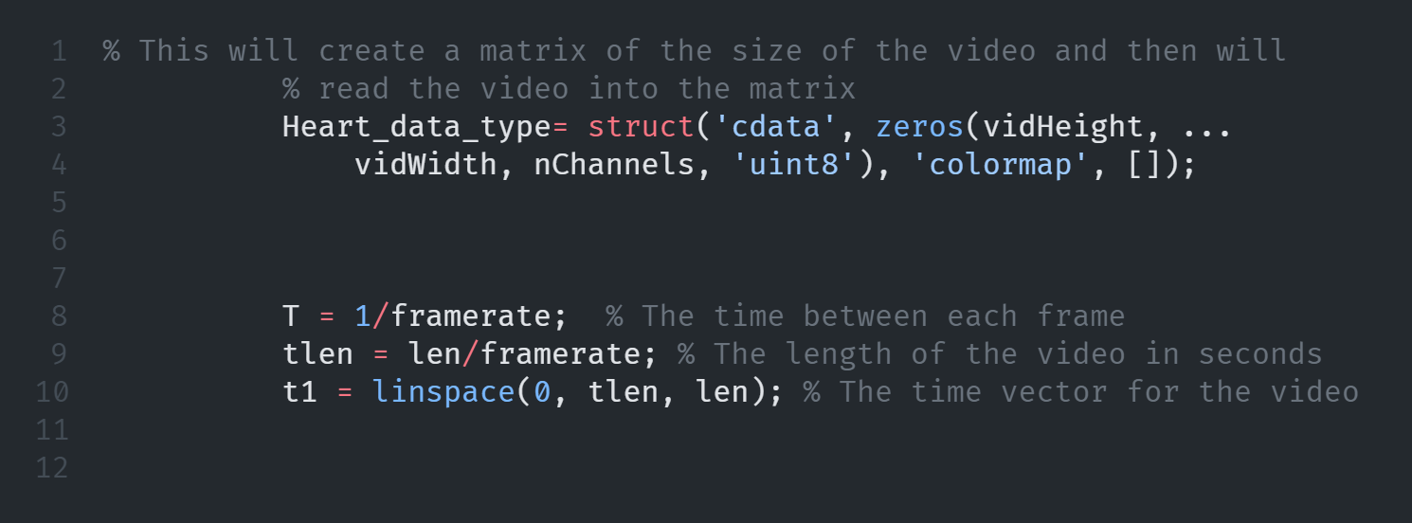

Figure 3 fucntion video size

f

Figure 4 frame rate

In this function, a matrix of the size of the video is generated based on the height, width, and channel of the video. After that, the function calculates the time period and time of the signal.

This function calculates f, and then moves the struct preallocated by its prototype based on the video's height, width, and channel. If we insert a video, the button will change to processing and be repositioned at the bottom.

Figure 5 Sample size

This the creation of app it’s self so we can call the function as an objects

And this defualt of configuration done by matlab

# 4. GUI



This and overlook of the GUI without loading the data

# 5. Implementation

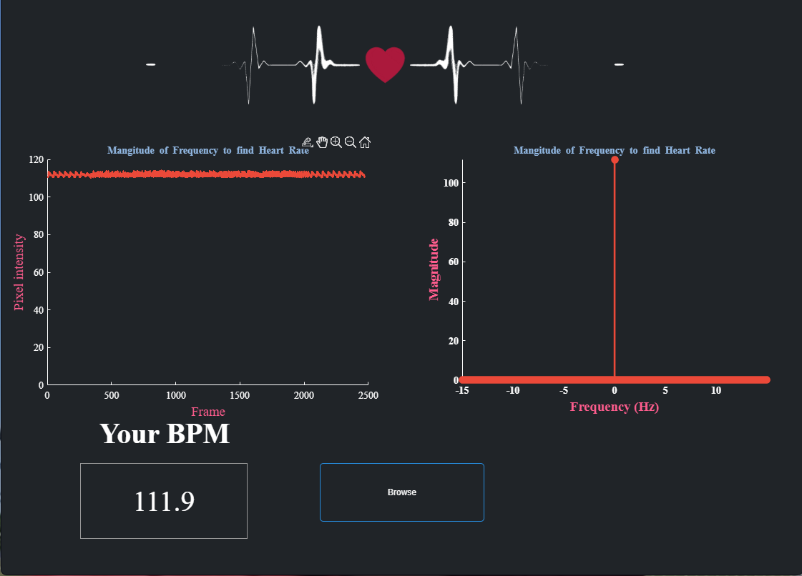

# 5.Conclusion

As a result of the implementation of the algorithm and the development of the GUI, we have achieved our objectives and have learned how we can apply our knowledge to solve problems. The next step in implementing this project will be to use hardware to collect data directly from users and analyze it.

# 6. Reference